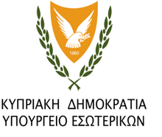
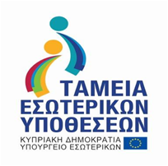

ΕΥΡΩΠΑΙΚΗ ΕΝΩΣΗ

Police training on the EU acquis (Union Acquis)
CY/2019/ISF/SO2.NO4.1/2

Date of Signing of the Agreement: 15/11/2019
Project Duration: 01/01/2018 – 30/06/2022
Project Budget: €220.803,06
The aim of the project CY / 2019 / ISF / SO2.NO4.1 / 2 is to conduct educational programs and informative visits (study visits) with the aim of strengthening business practices and controls at sea, and also trainings that will be conducted in the context of integration of the Republic of Cyprus in the Schengen area. Specifically, trainings will be held both in Cyprus and abroad on issues of intervention, immobilization and escort of boats (Sea Border Mobility). There will be exchanges of visits in order to implement good practices in matters of illegal immigration, ship and maritime operations, as well as training programs on: "Law of the Sea - Jurisdiction of the Republic of Cyprus" which will be organized by the Police Academy and which will include, among others, lecturers from abroad. Trainings for sea captain and engineers will also be conducted for the purposes of compliance and certification, with the provisions of the revised Convention for the Standards of Naval Training and Certification STCW-95. In addition, the Directorate of European Union and International Police Cooperation in cooperation with the Police Academy, will prepare and organize a series of specialized trainings that will be addressed to the members of the Police who serve in Services / Departments, directly related to the surveillance of the external borders of the Republic, as well as to Officers of other competent Ministries / Services. These trainings will provide the required knowledge and qualifications, so that the Republic can succeed in its evaluation and be crowned with success, the attempt for our country to join the Schengen area.
Between the dates 01/11/2019 - 30/04/2020 the following educational activities / information visits took place:
1. Schengen Contact Points / Assessment Coordinators training program (04-08/11/2019)
2. Training of Cypriot trainers in Cyprus in the field of control of professional intervention ships at sea (Instructor visit of the National Training Center of the French Gendarmerie) (11-15/11/2019)
3. Conducting an educational program on: "Law of the Sea" - (11-12/12/2019)
4. Τraining program for contact- point users for SIRENE and International Police Cooperation members for Schengen evaluation (SIS-SIRENE) (07-16/01/2020)
5. Τraining program for contact- point users for SIRENE and International Police Cooperation members for Schengen evaluation (SIS-SIRENE) (20-30/01/2020)
6. Study visit to Athens for planning and coordination of activities, in the framework of the preparation for the Schengen evaluation (SIS-SIRENE) (18-21/02/2020)

The project is co-financed by 90% by the EU Internal Security Fund and by 10% by the Republic of Cyprus.

